Russell Bjella

ASEN 6008

Lab 2 – Intro Part 2

2/8/2017

**Target Finite Burn to Raise Apogee**

1. 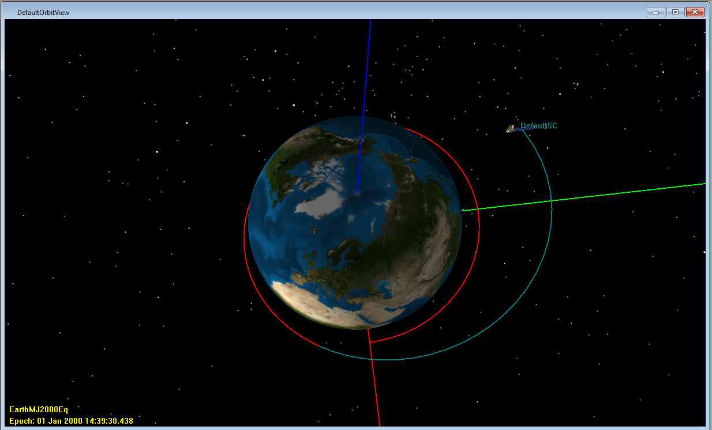Screen capture of simulated orbit
2. Command Summary
3. ****** Changes made to the mission will not be reflected ******
4. ****** in the data displayed until the mission is rerun ******
5. Propagate Command: Prop BurnDuration
6. Spacecraft : DefaultSC
7. Coordinate System: EarthMJ2000Eq
8. Time System Gregorian Modified Julian
9. ----------------------------------------------------------------------
10. UTC Epoch: 01 Jan 2000 13:32:43.922 21545.0643972480
11. TAI Epoch: 01 Jan 2000 13:33:15.922 21545.0647676184
12. TT Epoch: 01 Jan 2000 13:33:48.106 21545.0651401184
13. TDB Epoch: 01 Jan 2000 13:33:48.106 21545.0651401175
14. Cartesian State Keplerian State
15. --------------------------- --------------------------------
16. X = 6765.4740003992 km SMA = 9582.2027904178 km
17. Y = -3226.2851425451 km ECC = 0.2544968636324
18. Z = 811.36637400990 km INC = 12.858041327042 deg
19. VX = 4.2174973212297 km/sec RAAN = 306.19509708325 deg
20. VY = 6.6013719522497 km/sec AOP = 346.76780471375 deg
21. VZ = 1.6667355846354 km/sec TA = 42.153515224846 deg
22. MA = 25.131809702841 deg
23. EA = 33.093451885464 deg
24. Spherical State Other Orbit Data
25. --------------------------- --------------------------------
26. RMAG = 7539.1557659966 km Mean Motion = 6.730864552e-004 deg/sec
27. RA = -25.495305420499 deg Orbit Energy = -20.798998425425 km^2/s^2
28. DEC = 6.1781556710573 deg C3 = -41.597996850849 km^2/s^2
29. VMAG = 8.0089576609955 km/s Semilatus Rectum = 8961.5764171723 km
30. AZI = 78.701502515314 deg Angular Momentum = 59766.950034453 km^2/s
31. VFPA = 81.823250646688 deg Beta Angle = -17.178837499115 deg
32. RAV = 57.426225591113 deg Periapsis Altitude = 765.42593356647 km
33. DECV = 12.011553510837 deg VelPeriapsis = 8.3665471203734 km/s
34. VelApoapsis = 4.9719431746884 km/s
35. Orbit Period = 9334.8859698851 s
36. Planetodetic Properties
37. ---------------------------
38. LST = 334.50491426315 deg
39. MHA = 303.70858391173 deg
40. Latitude = 6.2124107997115 deg
41. Longitude = 30.796330351418 deg
42. Altitude = 1161.2680670690 km
43. Spacecraft Properties
44. ------------------------------
45. Cd = 2.200000
46. Drag area = 15.00000 m^2
47. Cr = 1.800000
48. Reflective (SRP) area = 1.000000 m^2
49. Dry mass = 850.00000000000 kg
50. Total mass = 1193.7699073421 kg
51. Tank masses:
52. ChemicalTank1: 343.76990734215 kg
53. The DC1 required 13 iterations.
54. The final burn duration was 1213.19 seconds.
55. The DV of the finite burn was 885.84 m/s (0.88584 km/s). The theoretical DV for an impulsive burn at periapsis is 0.83589 km/s. If a finite burn was executed to this theoretical DV, the final apogee would be lower than the desired 12000 km due to cosine losses. This is why the value computed by GMAT is higher than the theoretical value.
56. Based on the initial and final propellant masses, the burn required 412.2301 kg of fuel.

**Mars B-plane Targeting**

1. The TCM delta-V is 0.0072436383880 km/s.
2. The MOI delta-V is 1.6034398477259 km/s and used 1076.0639629571 kg of propellant.
3. SolarSystemView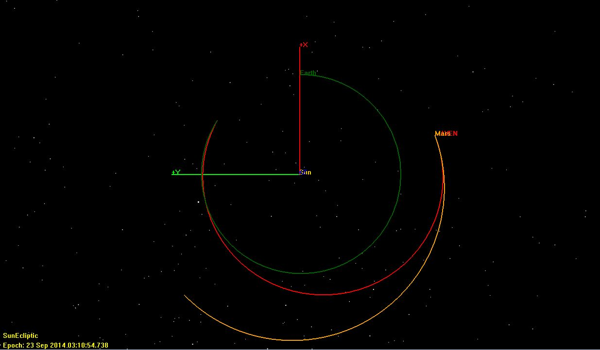
4. MarsView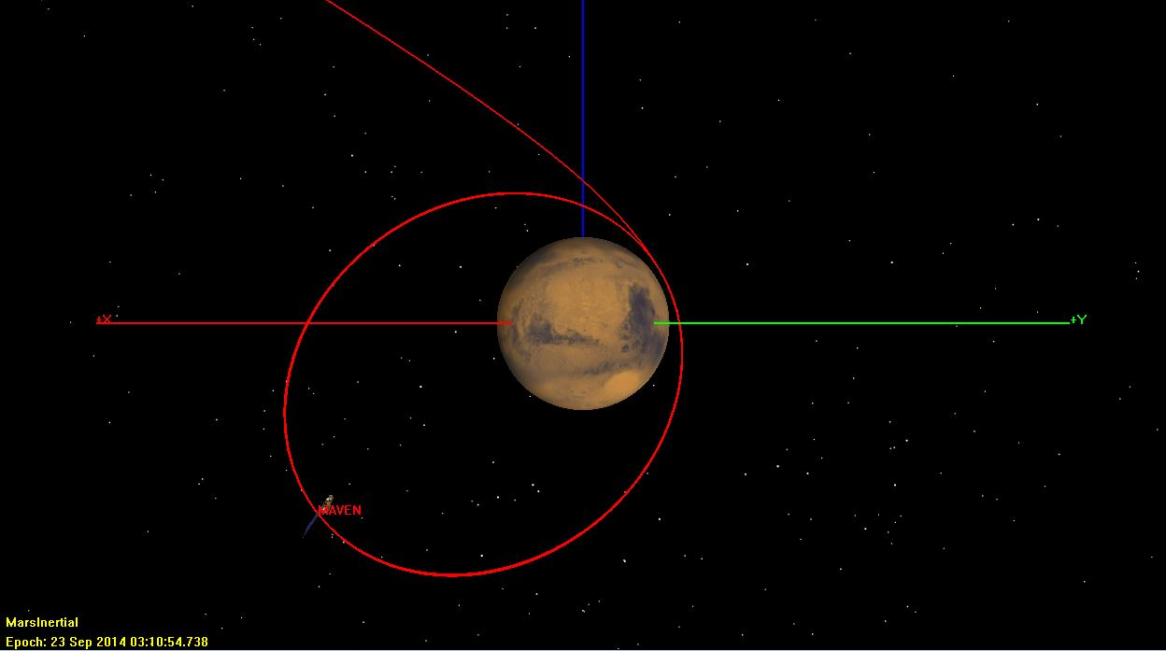
5. Setting the Achieve goal to MAVEN.Mars.OrbitPeriod with a value of 180,000 seconds, the delta-V for MOI is 1.1282118468898 km/s. The semimajor axis is 32757.097856083 km.
6. The radius at apoapsis is 61563.468275708 km.